|  |
| --- |
| **ente**  **User manual** |

**[Michaela Golhova 266099]**

**[Michal Pompa 266494]**

**[Matej Michalek ]**

**[Daniela Koch]**

**Introduction**

This document contains all information about an usage of **ente application**. Following descriptions will guide you through whole software and its functionalities.

Before you start using this application, please, read following instruction carefully.

**WARNING:**

This application is made for all students, parents and teacher of ente school. Do not try to entry to the application if :

* you are not a student/parent/teacher of mentioned school
* you’re account is not created yet

In case of any problem with usage of the application, please contact administrator.

Note that system doesn’t provide every functionality yet. From that reason, they are not explain in this manual. They will be added later.

**Table of content**

1.Login to system……………………………………………………………………………....4

2.Home page for student and homework……………………………………………………5

3.Home page for parent…………………………………………………………………….....6

4.Home page for teacher……………………………………………………………………...7

4.1 Create a homework……………………………………………………………….8

5.Home page for administrator………………………………………………………………..9

5.1 Create a new student/parent…………………………………………………...10

5.2 Edit user…………………………………………………………………………..11

5.3 Delete user or family…………………………………………………………….12

# LOGIN TO SYSTEM

For login to the system you need to fill following information : **1.username**(which is your email address) and **2.password.** Then press the button **3.login.**

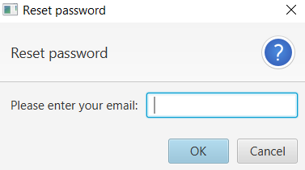

If you forgot your password, click **reset password** which is under *login button.*

Then write your email address to an empty text field and you will received an email with a new password.

**2. HOME PAGE FOR STUDENT AND HOMEWORK**  
The student main page contains **1.student’s profile, 2.list of homeworks** and **3.messages**. In main panel is displayed an example of homework. Every homework has **4.title, 5.content, 6.deadline** and **7.submit button.** As a student you must submit your homework until deadline above the *button submit.*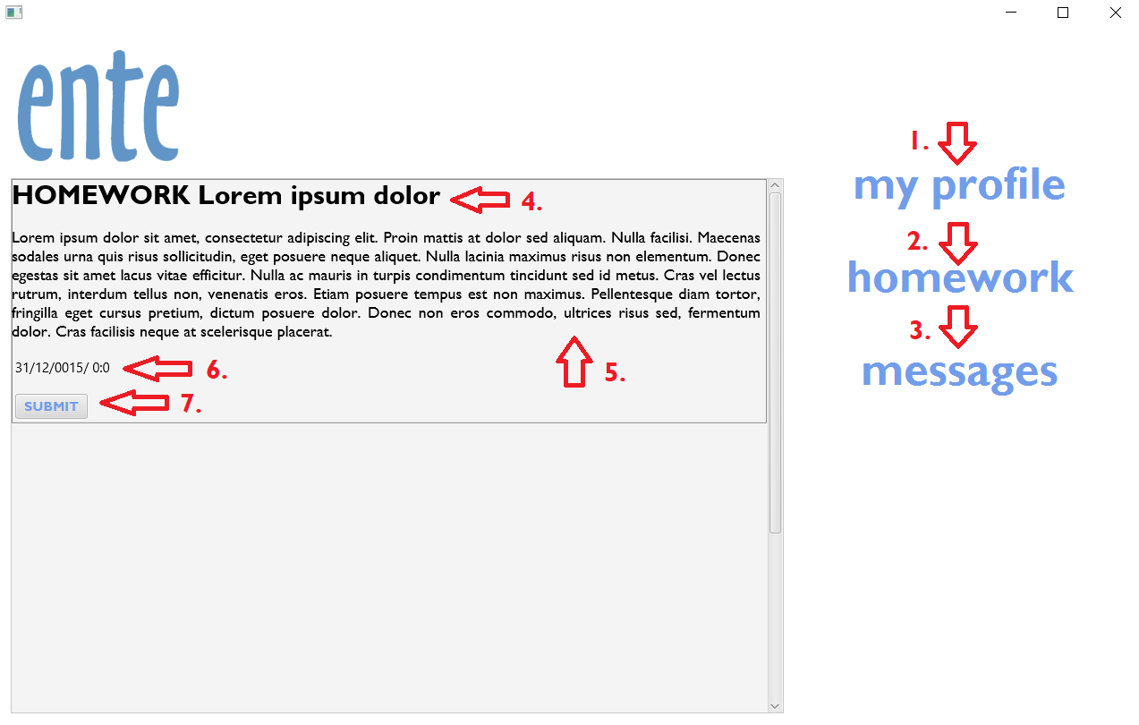

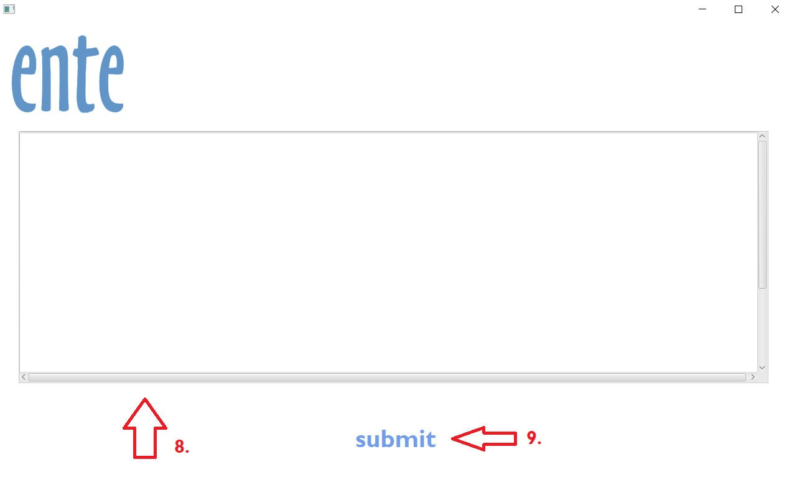

After pressing **7.submit button**, the new window will be open with **8.text area** where you can write your solution. Then click **9.submit** and your homework will be added to the system. The **8.submit button** will be changed to **edit button** and you can change your solution until deadline! If you want to go back, click ente logo.

**3. HOME PAGE FOR PARENT**

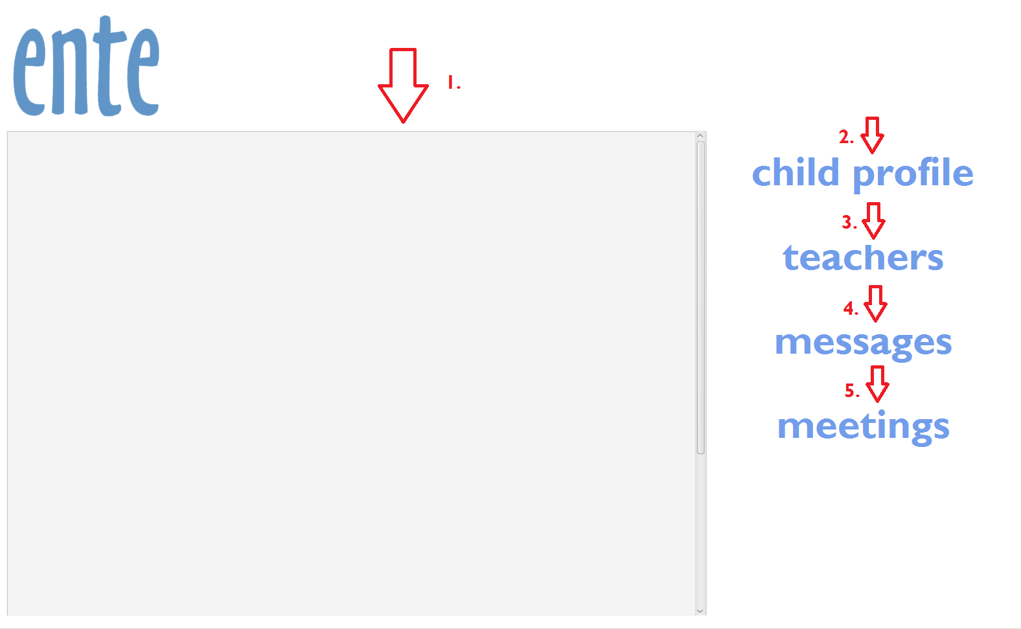

The parent main page contains **1. panel** with announcements, **2.child profile** where is an information about child and child’s history of activity. As a parent you are able to check *homeworks* without uploaded solution.

**3. teacher list** which contains a teacher name and email address. **4. messages** and **5.meeting calendar.**

System doesn’t provide functionality for parent. They will be added and explained later.

**4. HOME PAGE FOR TEACHER**

The teacher main page contains **1.post, 2.homework** where you can create a new post/homework. *More information in the next page*.**3.messages, 4.meeting calendar** and **5.panel** with announcements and homeworks. 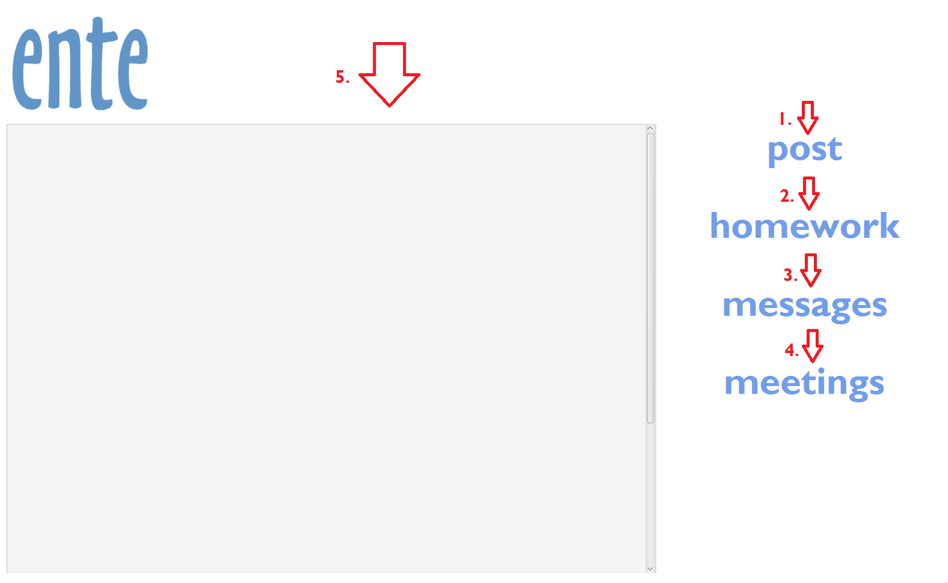

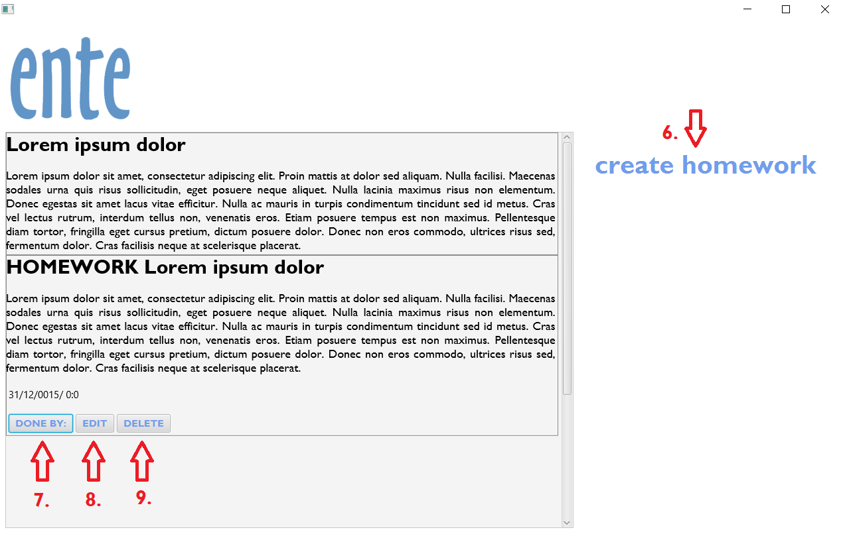After pressing **2.homework**, the new window will be displayed with an option to **6.create a new homework**. In already exist homework you can check **7.who done** homework, or **8.edit** created homework and **9.delete** homework**.** If you want to go back, click ente logo.

**4.1 CREATE A HOMEWORK**

In creating homework window every field has to be filled! 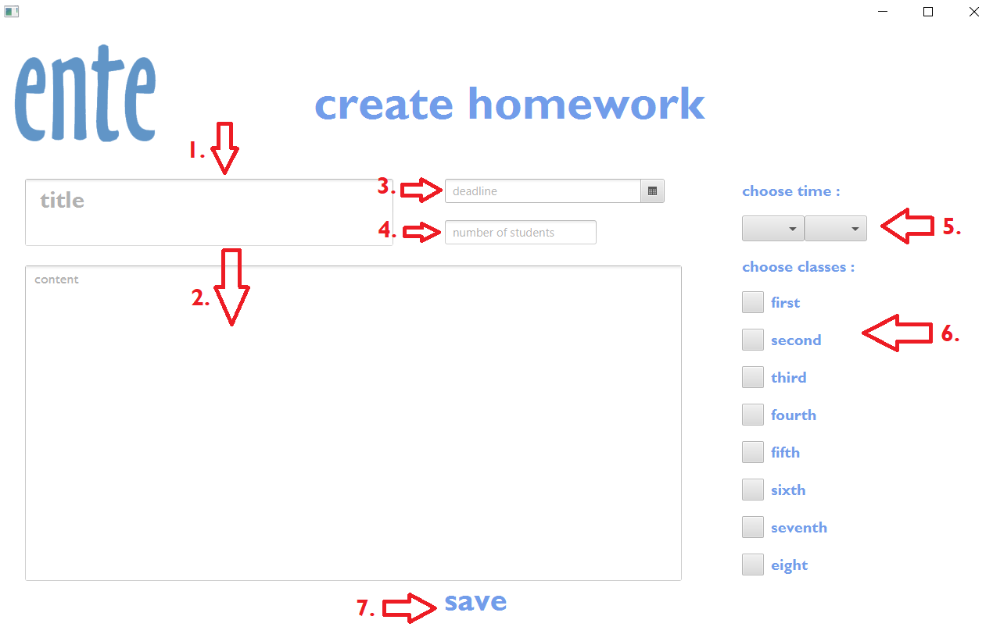

**1.title** of homework, **2.content** criteria of homework, **3.deadline** with **5. ending time**. **4.number** **of students** to delivered and **6.class**.

If every field was filled correctly, then you are able to save a new homework. The homework will be added to the system and displayed in teacher’s and student’s main panel.

If you want to go back, click ente logo.

**5. HOME PAGE FOR ADMINISTRATOR**

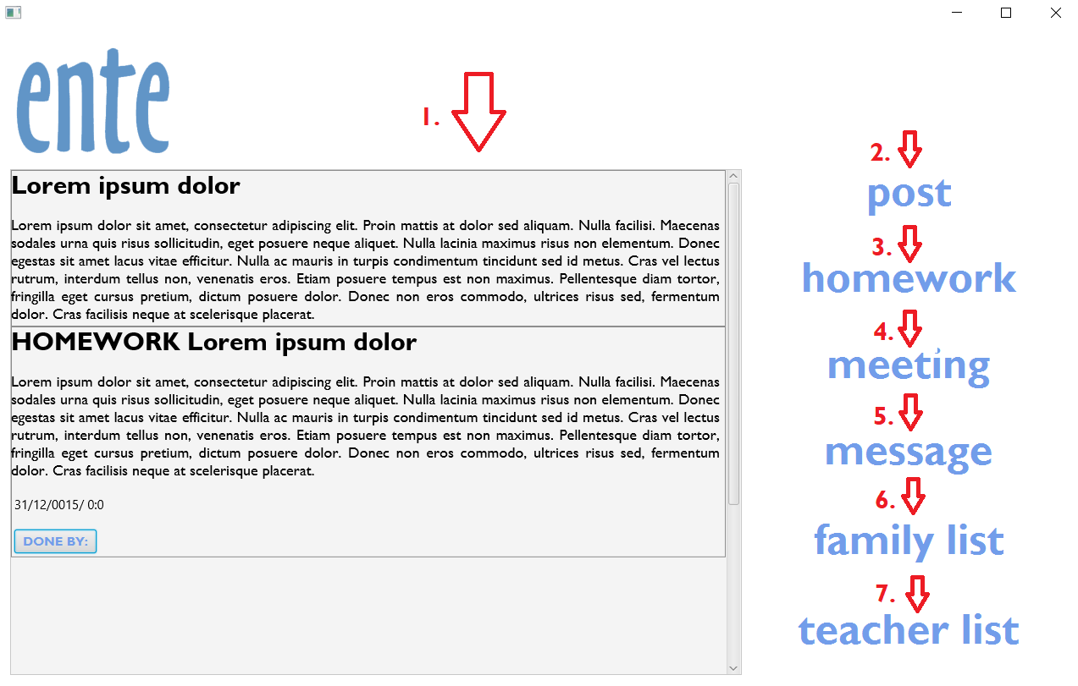

The administrator home page contains more functionality. **1.panel** with announcements and homeworks, **2.post, 3.homework** where you can create post or homework. See more in *4.1 create homework*. **4.meeting calendar, 5.messages, 6.family list** and **7.teacher list** where are all information about users.

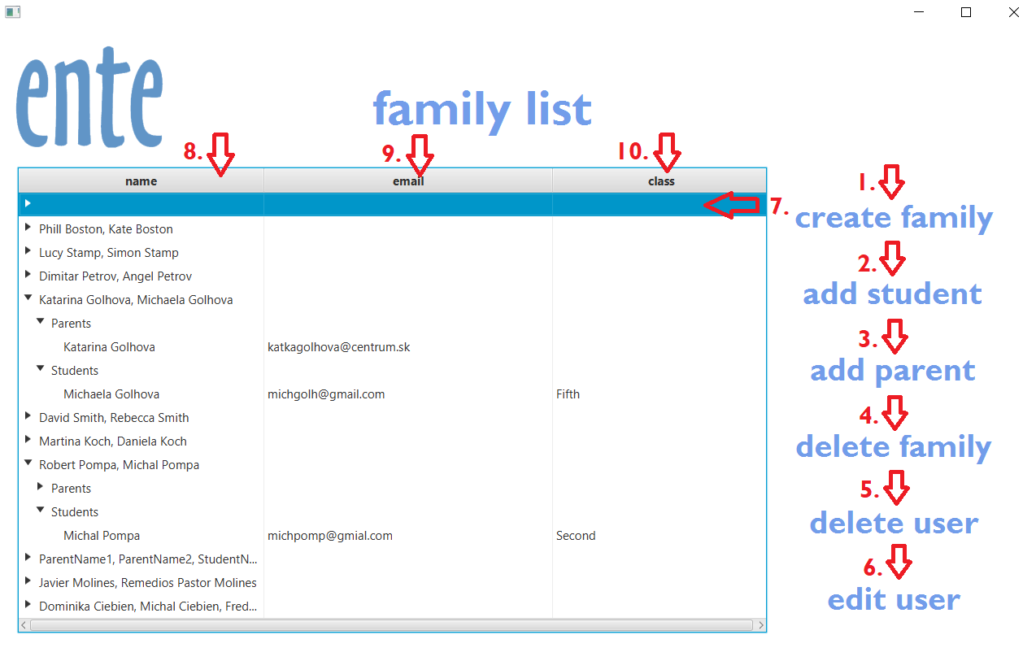**5.1 CREATE NEW STUDENT/PARENT**

The administrator is only type of user with privilege of creating a new users. The family list is located in the administrator main page.

In order to create a student or parent, their family has to be created first! First, press button **1.create family**. In the table will appear an **7.empty row**. Before you click **2.add student** or **3.add parent**, be sure that **7.empty row** is selected. (If it’s selected, it changes color to blue). 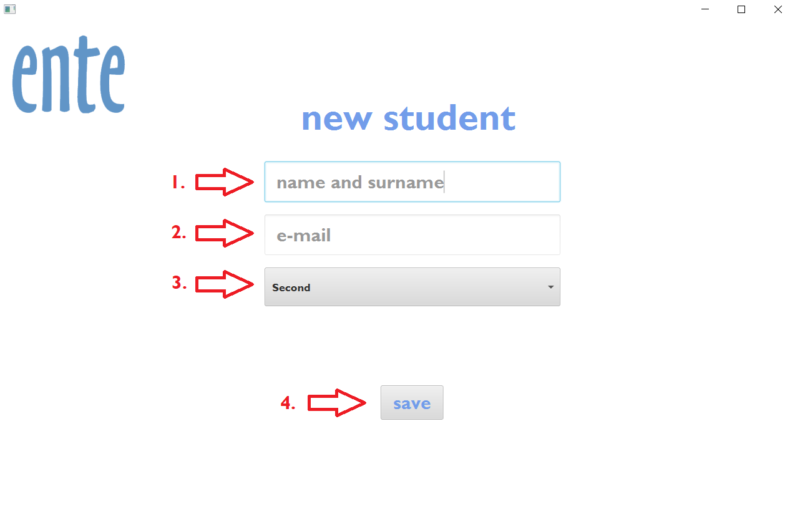

In case of new student, fill **1.name and surname, 2.email address, 3.class.** Then click button save. A new student will be added to the system and displayed in family table. In case of new parent fill **1.name and surname** and **2.email address.** If you want to go back, click ente logo.

**5.2 EDIT USER**

Open **8.family name**, in family choose an user with **9.email** (and **10.class** in case of student) . Then click **6.edit user**. A new window will be open with old informations of chosen user. After rewriting informations, click a button save. The user will be overridden in the system and changed user will be displayed in the family table. If you want to go back, click ente logo.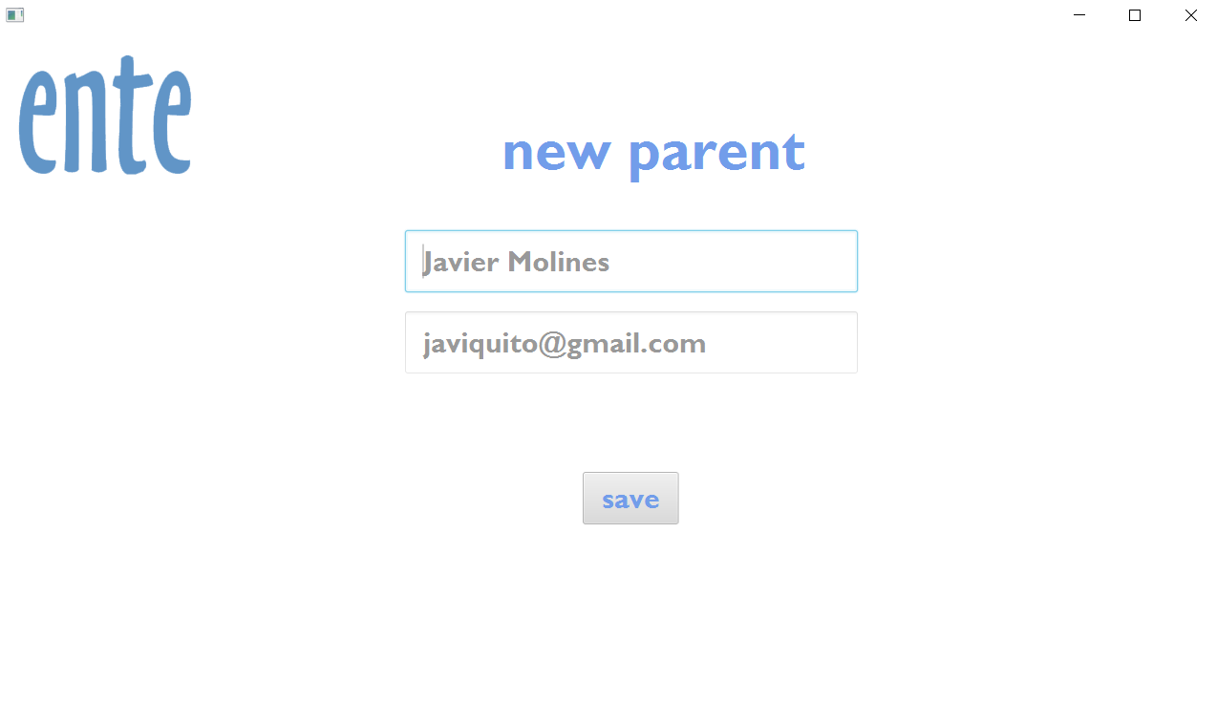

**5.3 DELETE USER OR FAMILY**

**Delete user:**

Open **8.family name**, in family choose an user with **9.email** (and **10.class** in case of student) . Then click **5.delete user**. A dialog window will be open with question if you are sure that you want to delete chosen user. Confirm it by pressing button YES. Then user will be deleted from the database.

**Delete family:**

Click on family row where is displayed just family name. Then click **4.delete family**. A dialog window will be open with question if you are sure that you want to delete chosen user. Confirm it by pressing button *YES.*

In case of deleting family, every member of family will be deleted from the system!

If you want to go back, click ente logo.